

Subject: Fundamental of AI and ML
Project Title: Network Intrusion Detection System (NIDS) Using Machine Learning
Submitted by:
Name: Vanshika Verma
Registration number: 25BCY10171
Branch: Computer Science (Cyber security and digital forensic)
Submitted to: Dr. Satyabrata Nath

Table of Contents
- Introduction
- Problem Statement
- Objectives
- Scope of the Project
- Literature Overview
- Methodology
  - Dataset Description
  - Preprocessing
  - Model Selection
  - Training Process
  - Evaluation
- Results
- Screenshots
- Conclusion

INTRODUCTION
Network Intrusion Detection Systems (NIDS) help identify malicious network activity such as unauthorized access, abnormal connections, and cyber-attacks.
In this project, Machine Learning techniques are applied to the NSL-KDD dataset to detect whether a network request is normal or an attack.
This project demonstrates:
- Data preprocessing
- Feature engineering
- ML model training
- Evaluation and visualization
- Saving model for future predictions

PROBLEM STATEMENT

Traditional security systems often fail to detect new or modified cyber-attacks.
There is a need for an automated system that can analyze network traffic and classify it accurately.
Goal:
“Build a Machine Learning-based Intrusion Detection System that classifies network connections into Normal or Attack.”

OBJECTIVES

- Understand and apply AI/ML concepts.
- Clean and preprocess real-world security dataset.
- Train ML model for intrusion detection.
- Evaluate accuracy, precision, recall, and F1-score.
- Visualize results using heatmaps.
- Save model for real-time predictions

SCOPE OF THE PROJECT

- Detects network intrusions (binary classification).
- Suitable for cybersecurity, networking labs, ML labs.
- Can be extended to:
  - Deep learning
  - Multi-class attack classification
  - Real-time packet analysis

LITERATURE OVERVIEW (Simple Lines)

Past research shows that Machine Learning algorithms like Random Forest, SVM, and Neural Networks are widely used in intrusion detection.
Among them, Random Forest provides high accuracy and handles imbalanced datasets effectively.

METHODOLOGY

Dataset Description
- Dataset used: NSL-KDD
- Contains normal + attack records
Include screenshot: df.head()

Preprocessing Steps
- Remove duplicates
- Remove missing values
- Encode label (normal = 0, attack = 1)
- Identify categorical + numerical columns
- Apply StandardScaler + OneHotEncoder

Model Selection
Algorithm used:
- Random Forest Classifier (100 trees)
Reason:
- High accuracy
- Works well with mixed feature types
- Fast training

Training Process
Explain short:
- Preprocessed data used
- Train-test split (80:20 ratio)
- Model trained using RandomForestClassifier

Evaluation Metrics
Include screenshot:
- Classification report
- Confusion matrix heatmap

RESULTS

The Random Forest model achieved high accuracy on test data.
Observations:
- High precision for attack detection
- Low false negatives
- Confusion matrix indicates the model is reliable

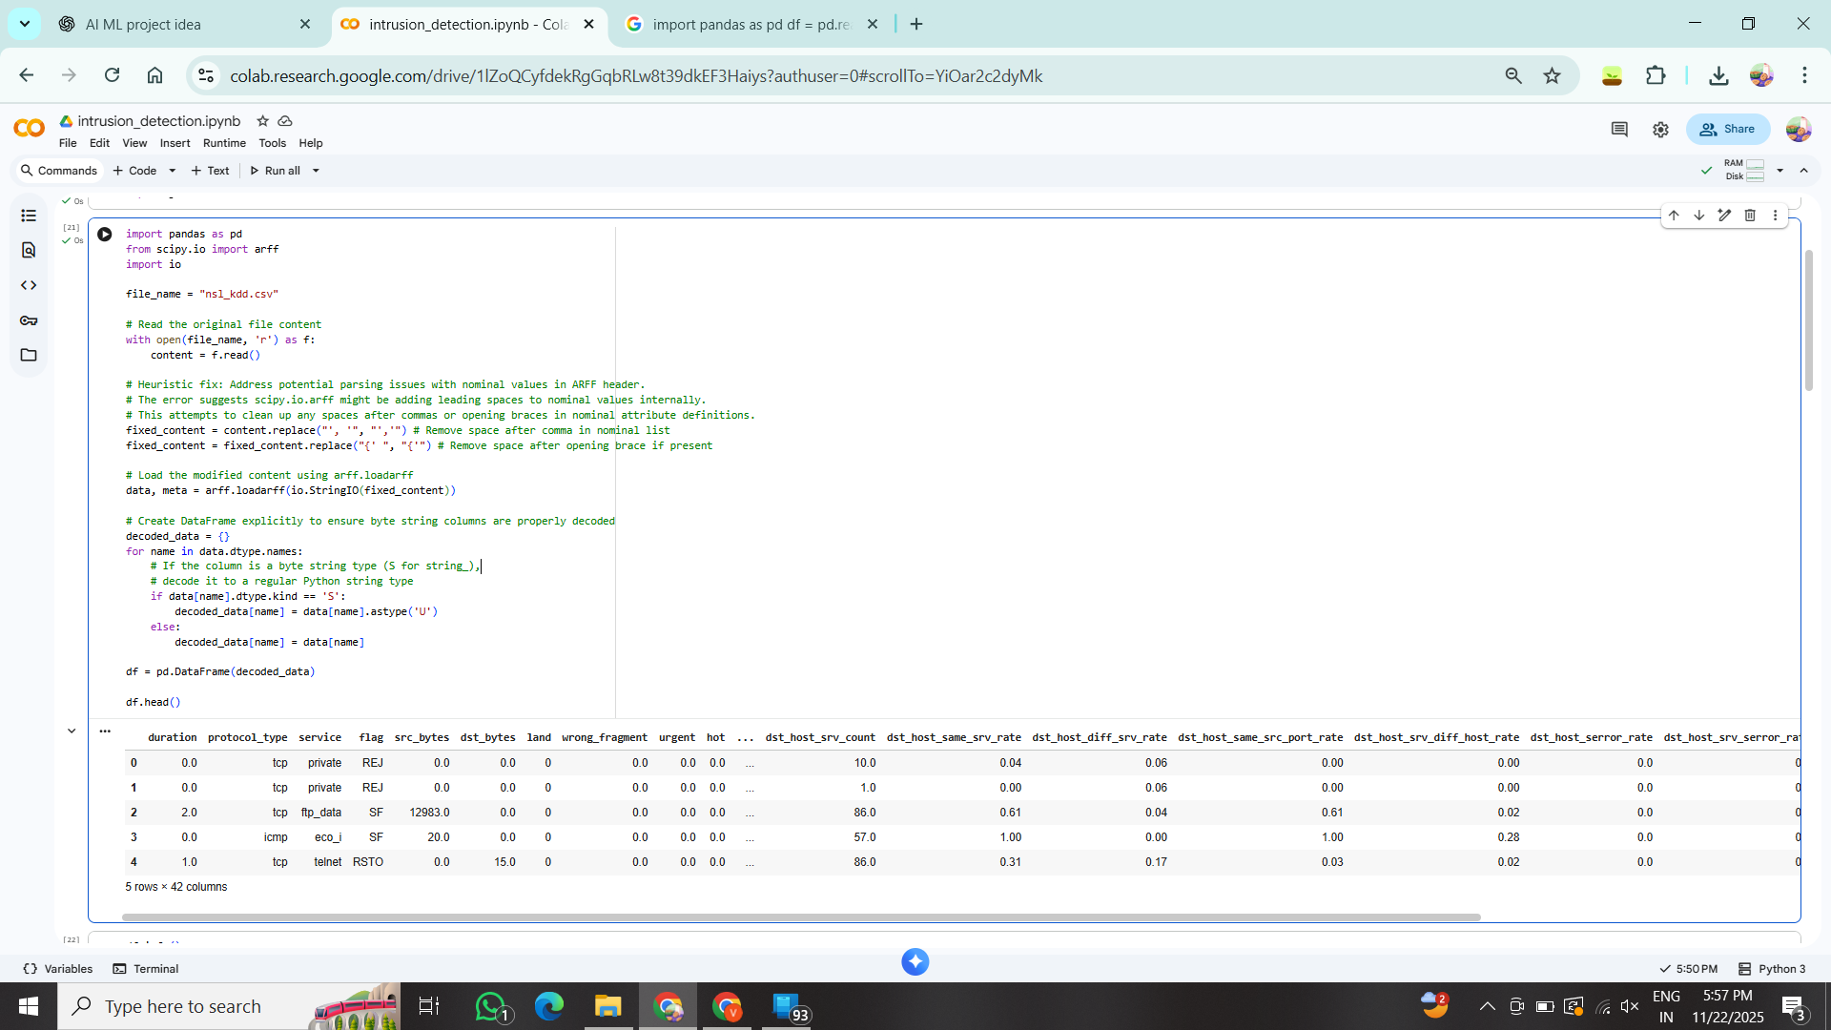
SCREENSHOTS SECTION
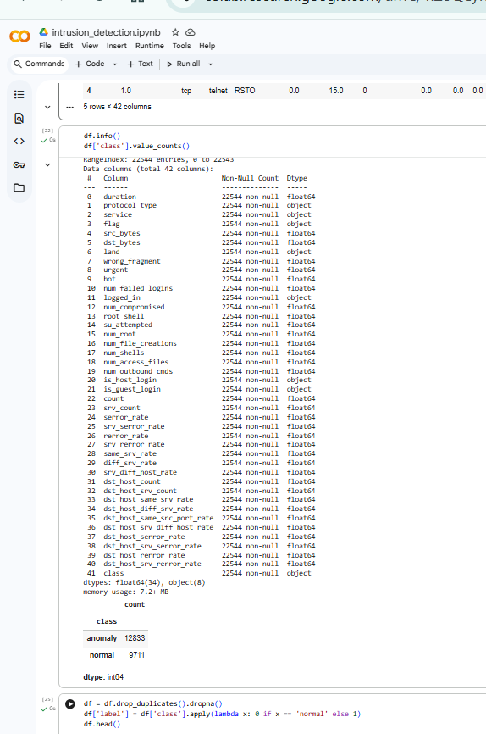



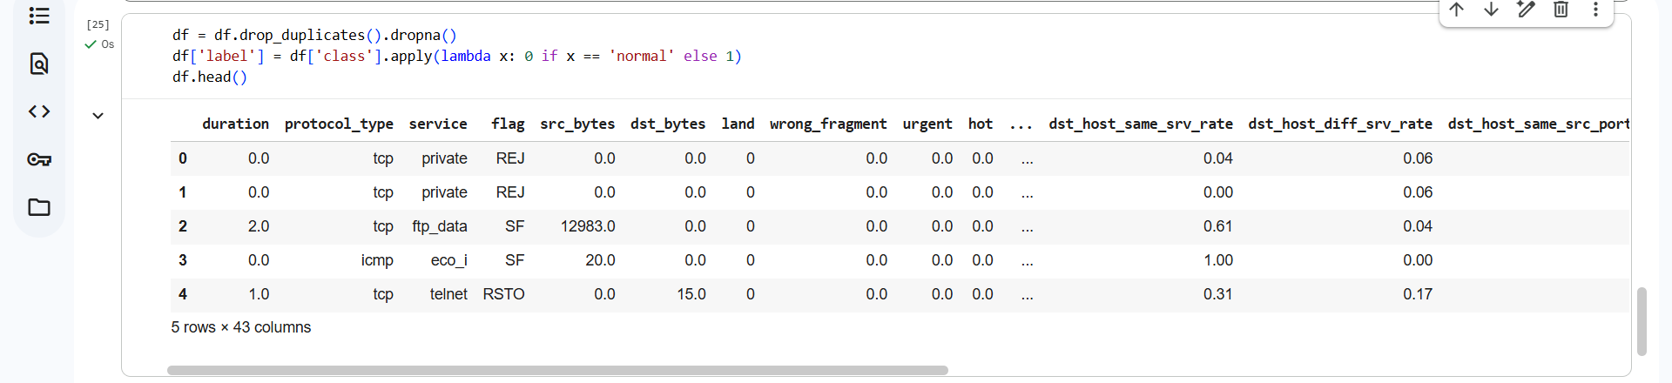


CONCLUSION

This project successfully demonstrates the use of Machine Learning in cyber security.
The NIDS model can accurately classify network connections into normal or attack.
It can be improved by:
- Using advanced ML algorithms
- Adding real-time network packet analysis
- Applying deep learning models

